When John Openshaw received an envelope containing five orange pips with the instruction: “Put the papers on the sundial.” he was terrified. His uncle and his father had received the same messages, shortly before they died. Did this portend his own death as well? He took the mystery to Sherlock Holmes.

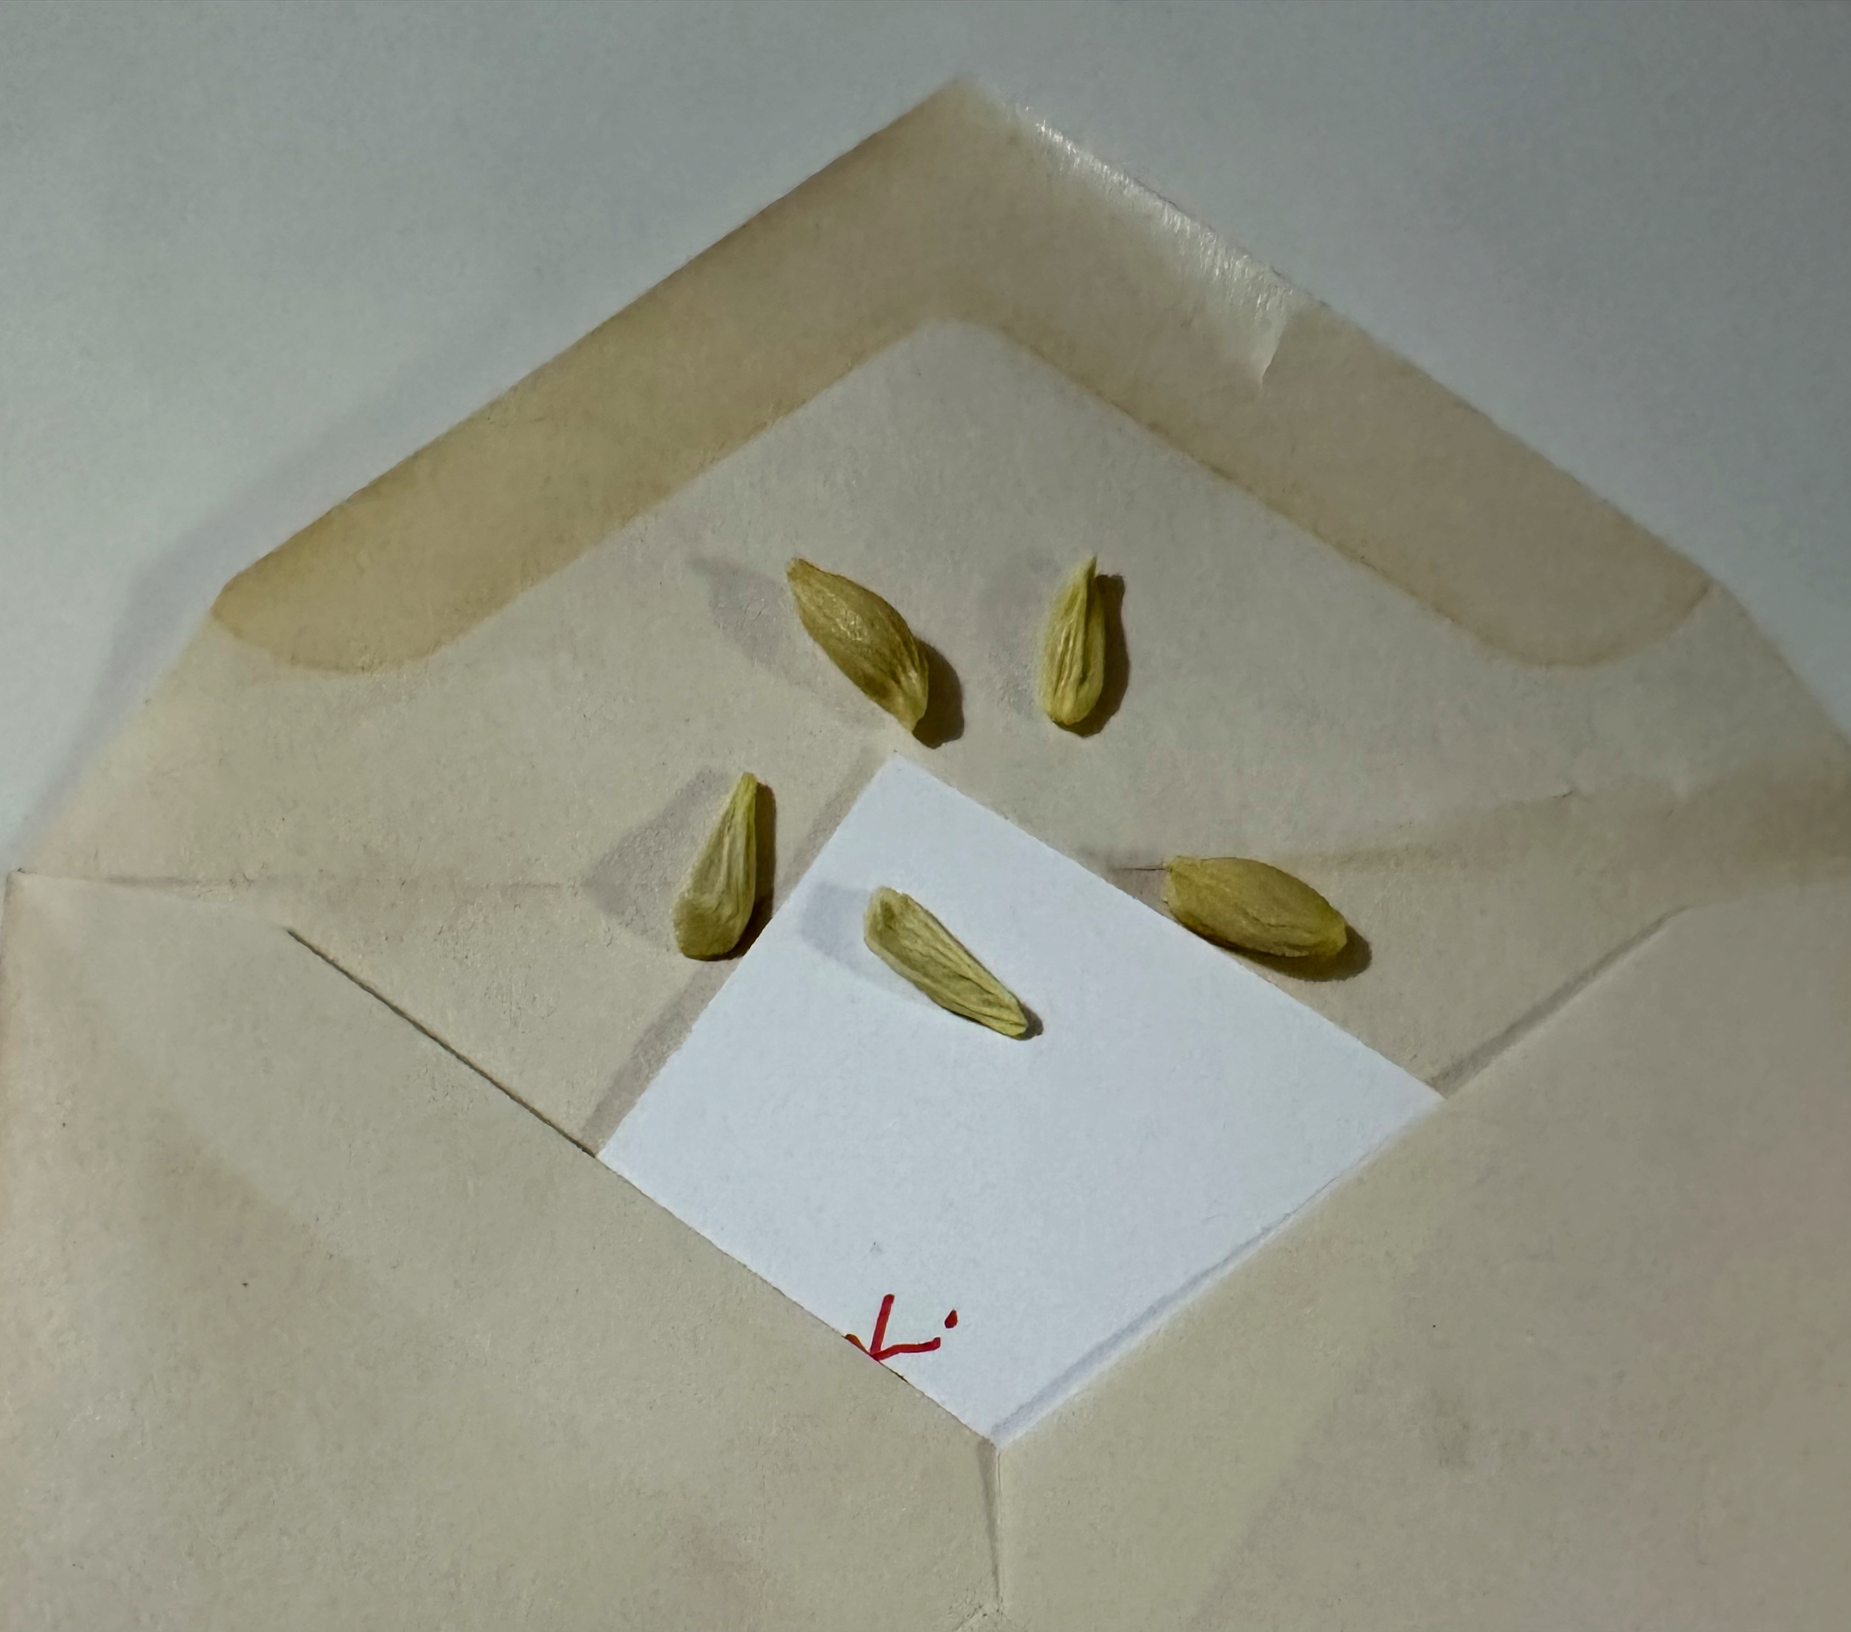

The Hudson Valley Sciontists

will consider “The Five Orange Pips”

Vassar College Alumnae House

Friday, May 24, 2024

6:00 pm cocktails (cash bar) 6:30 dinner

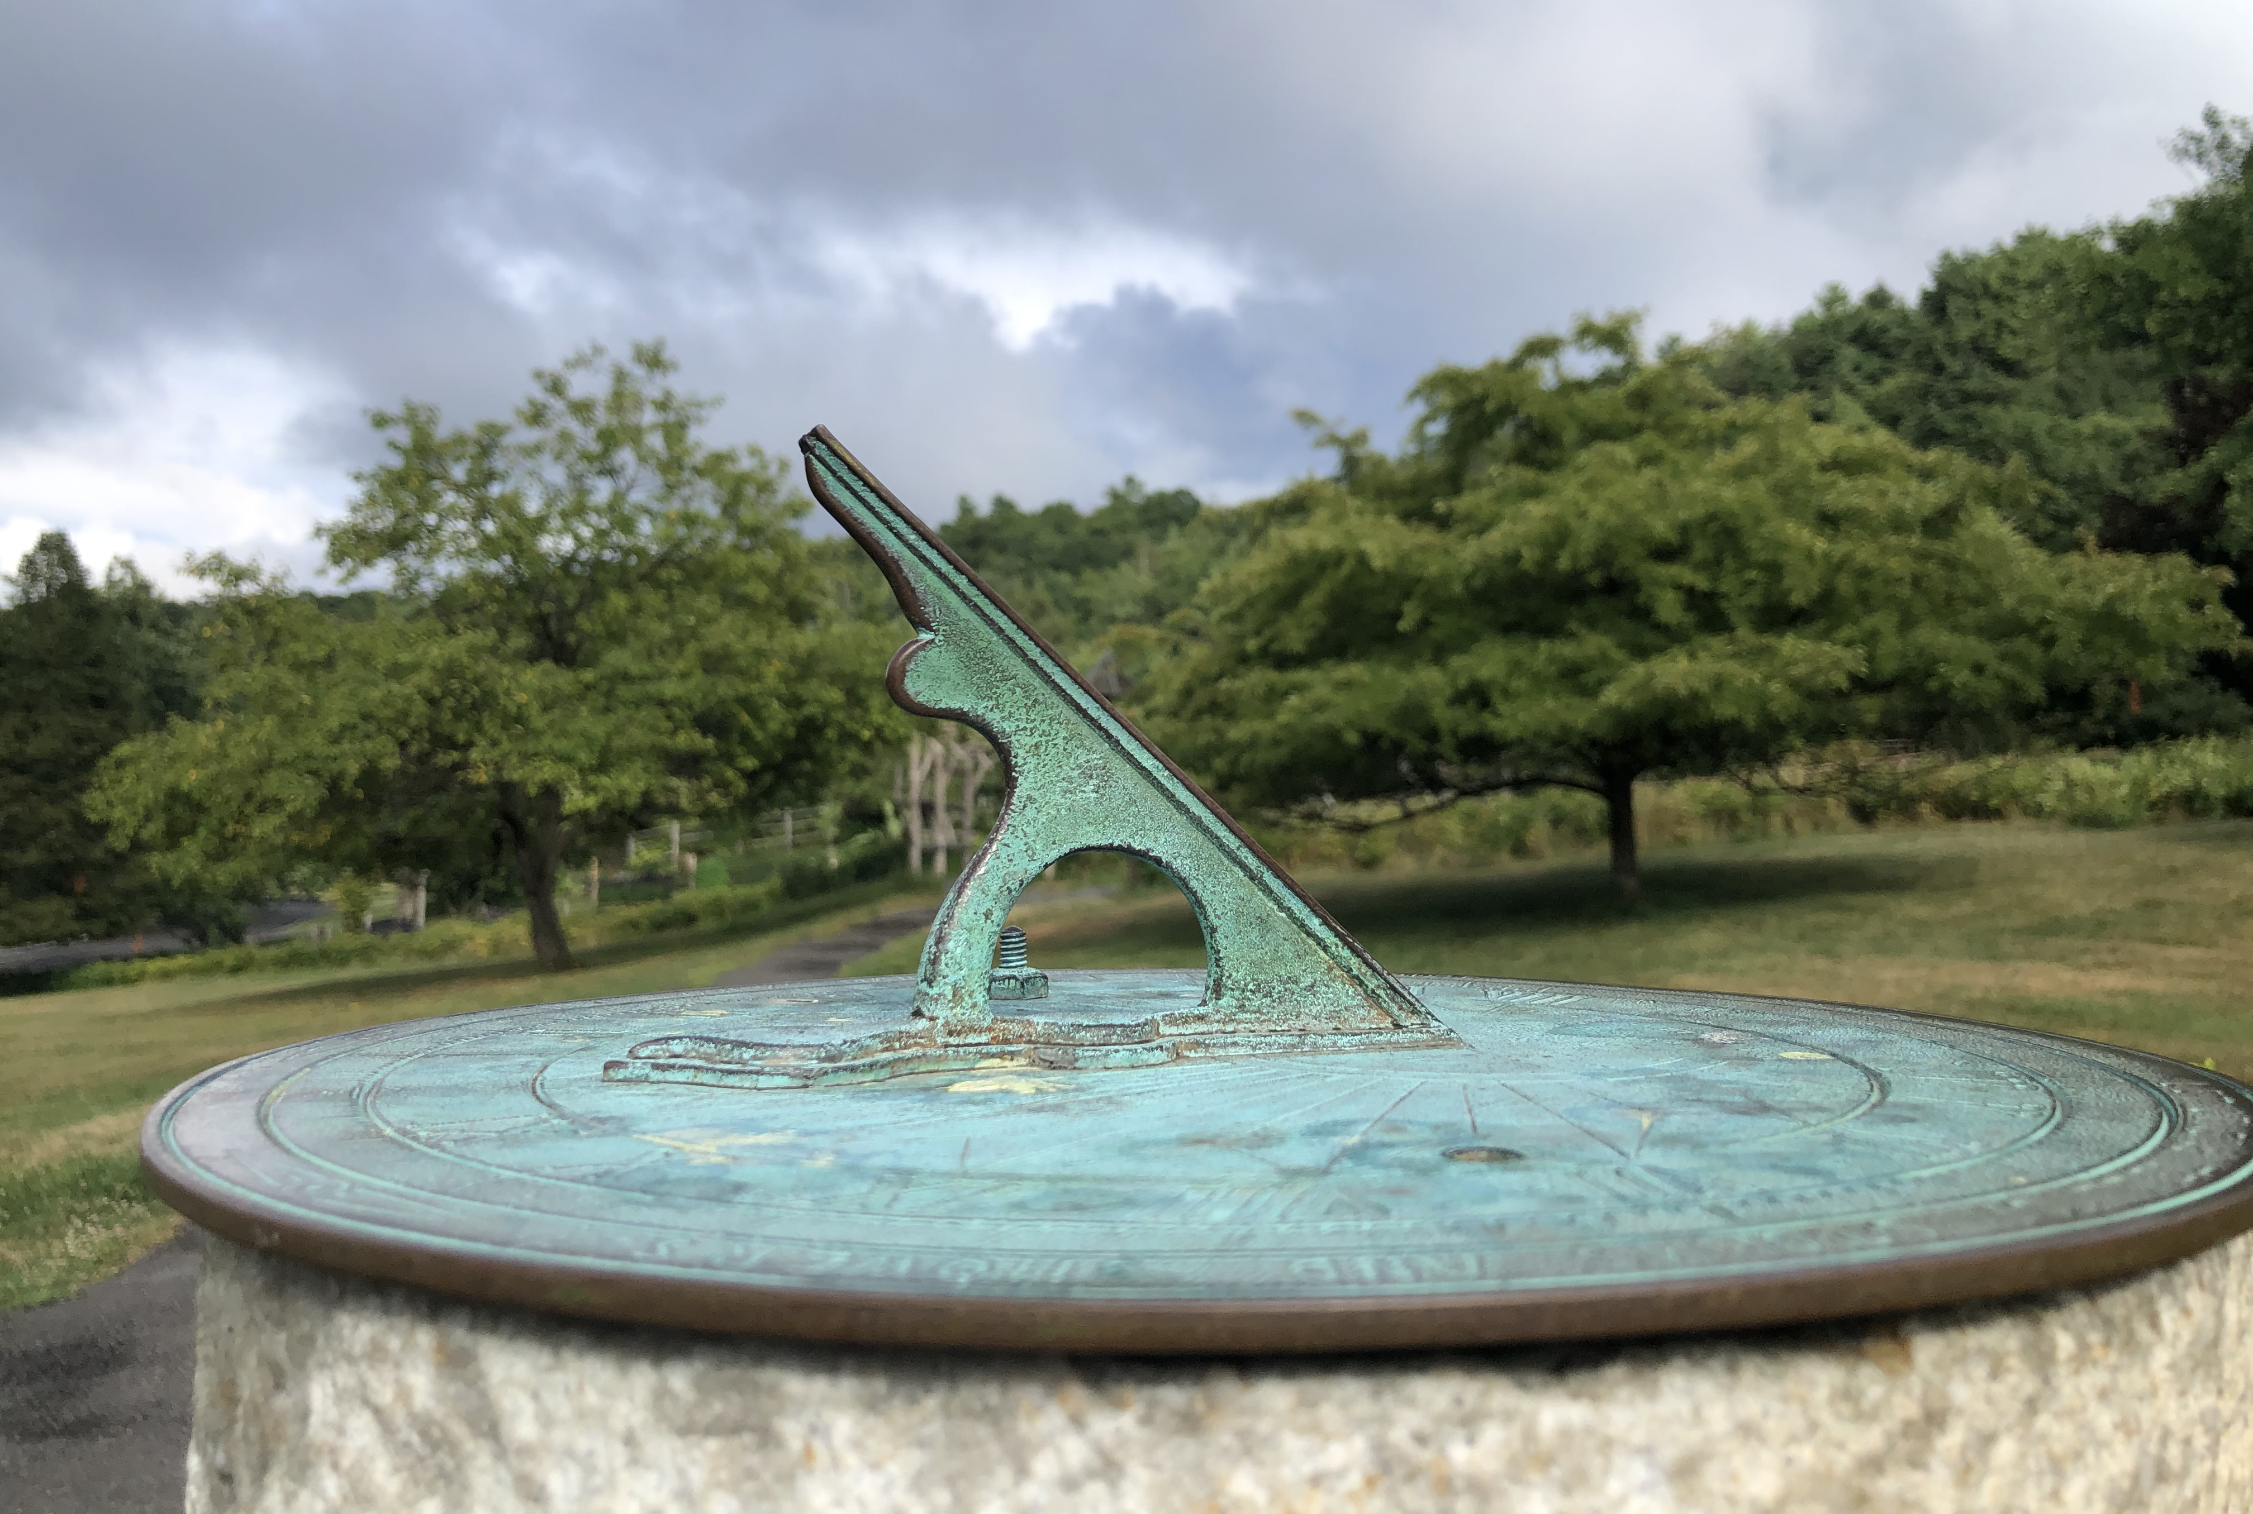

Reserve with check ($70 per person) to Linda Lant, 59 Coburn Drive, Poughkeepsie, NY 12603

For more information: loulewis221b@gmail.com or clewis1880a@gmail.com

JCR/2024

