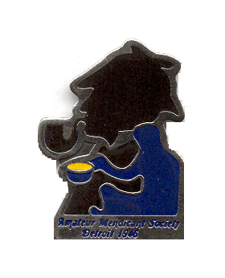Amateur Mendicant Society
Of Detroit, Established in 1946

Gasogene: Tidewaiter:
John Kramb (248) 470-2342 Chris Jeryan (248) 854-2180

Commissionaire: Tantalus:
Chris Music (248) 922-9739 Rob Musial (313) 885-9153

“My name is probably familiar to you.”

—Sherlock Holmes to Von Bork in “His Last Bow.”

His name is familiar to all of us and so we cordially invite you to join with like-minded friends for an evening of fine food and conversation at the spring meeting of the Amateur Mendicant Society of Detroit.

Saturday, April 20, 2024
6:00 p.m.
The Commonwealth Club
30088 Dequindre, Warren Club phone: (586) 751-9560

Our assigned story is “His Last Bow” in which Holmes impersonates an Irish-American named Altamont to defeat the German spy Von Bork – with the help of Dr. Watson and their housekeeper, Martha.

There will be a brief discussion of the story by David MacGregor, a Mendicant history minute by Chris Music plus presentations by two esteemed Sherlockians, Scott Monty and Steve Doyle.

Also included will be the usual toasts organized by Chris Music plus prizes and more. There will also be a Sherlockian “sell and swap meet” to thin or add to your collection, including books from the late member Jerry Alvin, with proceeds from that going to the Mendicant treasury.

To attend, please make checks for $31 to: Amateur Mendicant Society of Detroit and mail to the address below by FRIDAY, APRIL 12. Or visit PayPal at amateurmendicantsociety@gmail.com for instructions.
AMATEUR MENDICANT SOCIETY OF DETROIT
c/o Chris Jeryan
22129 Metamora Drive
Beverly Hills, MI 48025

The buffet includes pasta, chicken and beef entrees, potato, vegetables, a garden salad and dessert plus coffee, tea, and soft drinks. As always, there will also be a cash bar.

“Come at once if convenient … if inconvenient, come all the same.”

